Assessment task — Australia in a diverse world: Sources

Source 1
World map
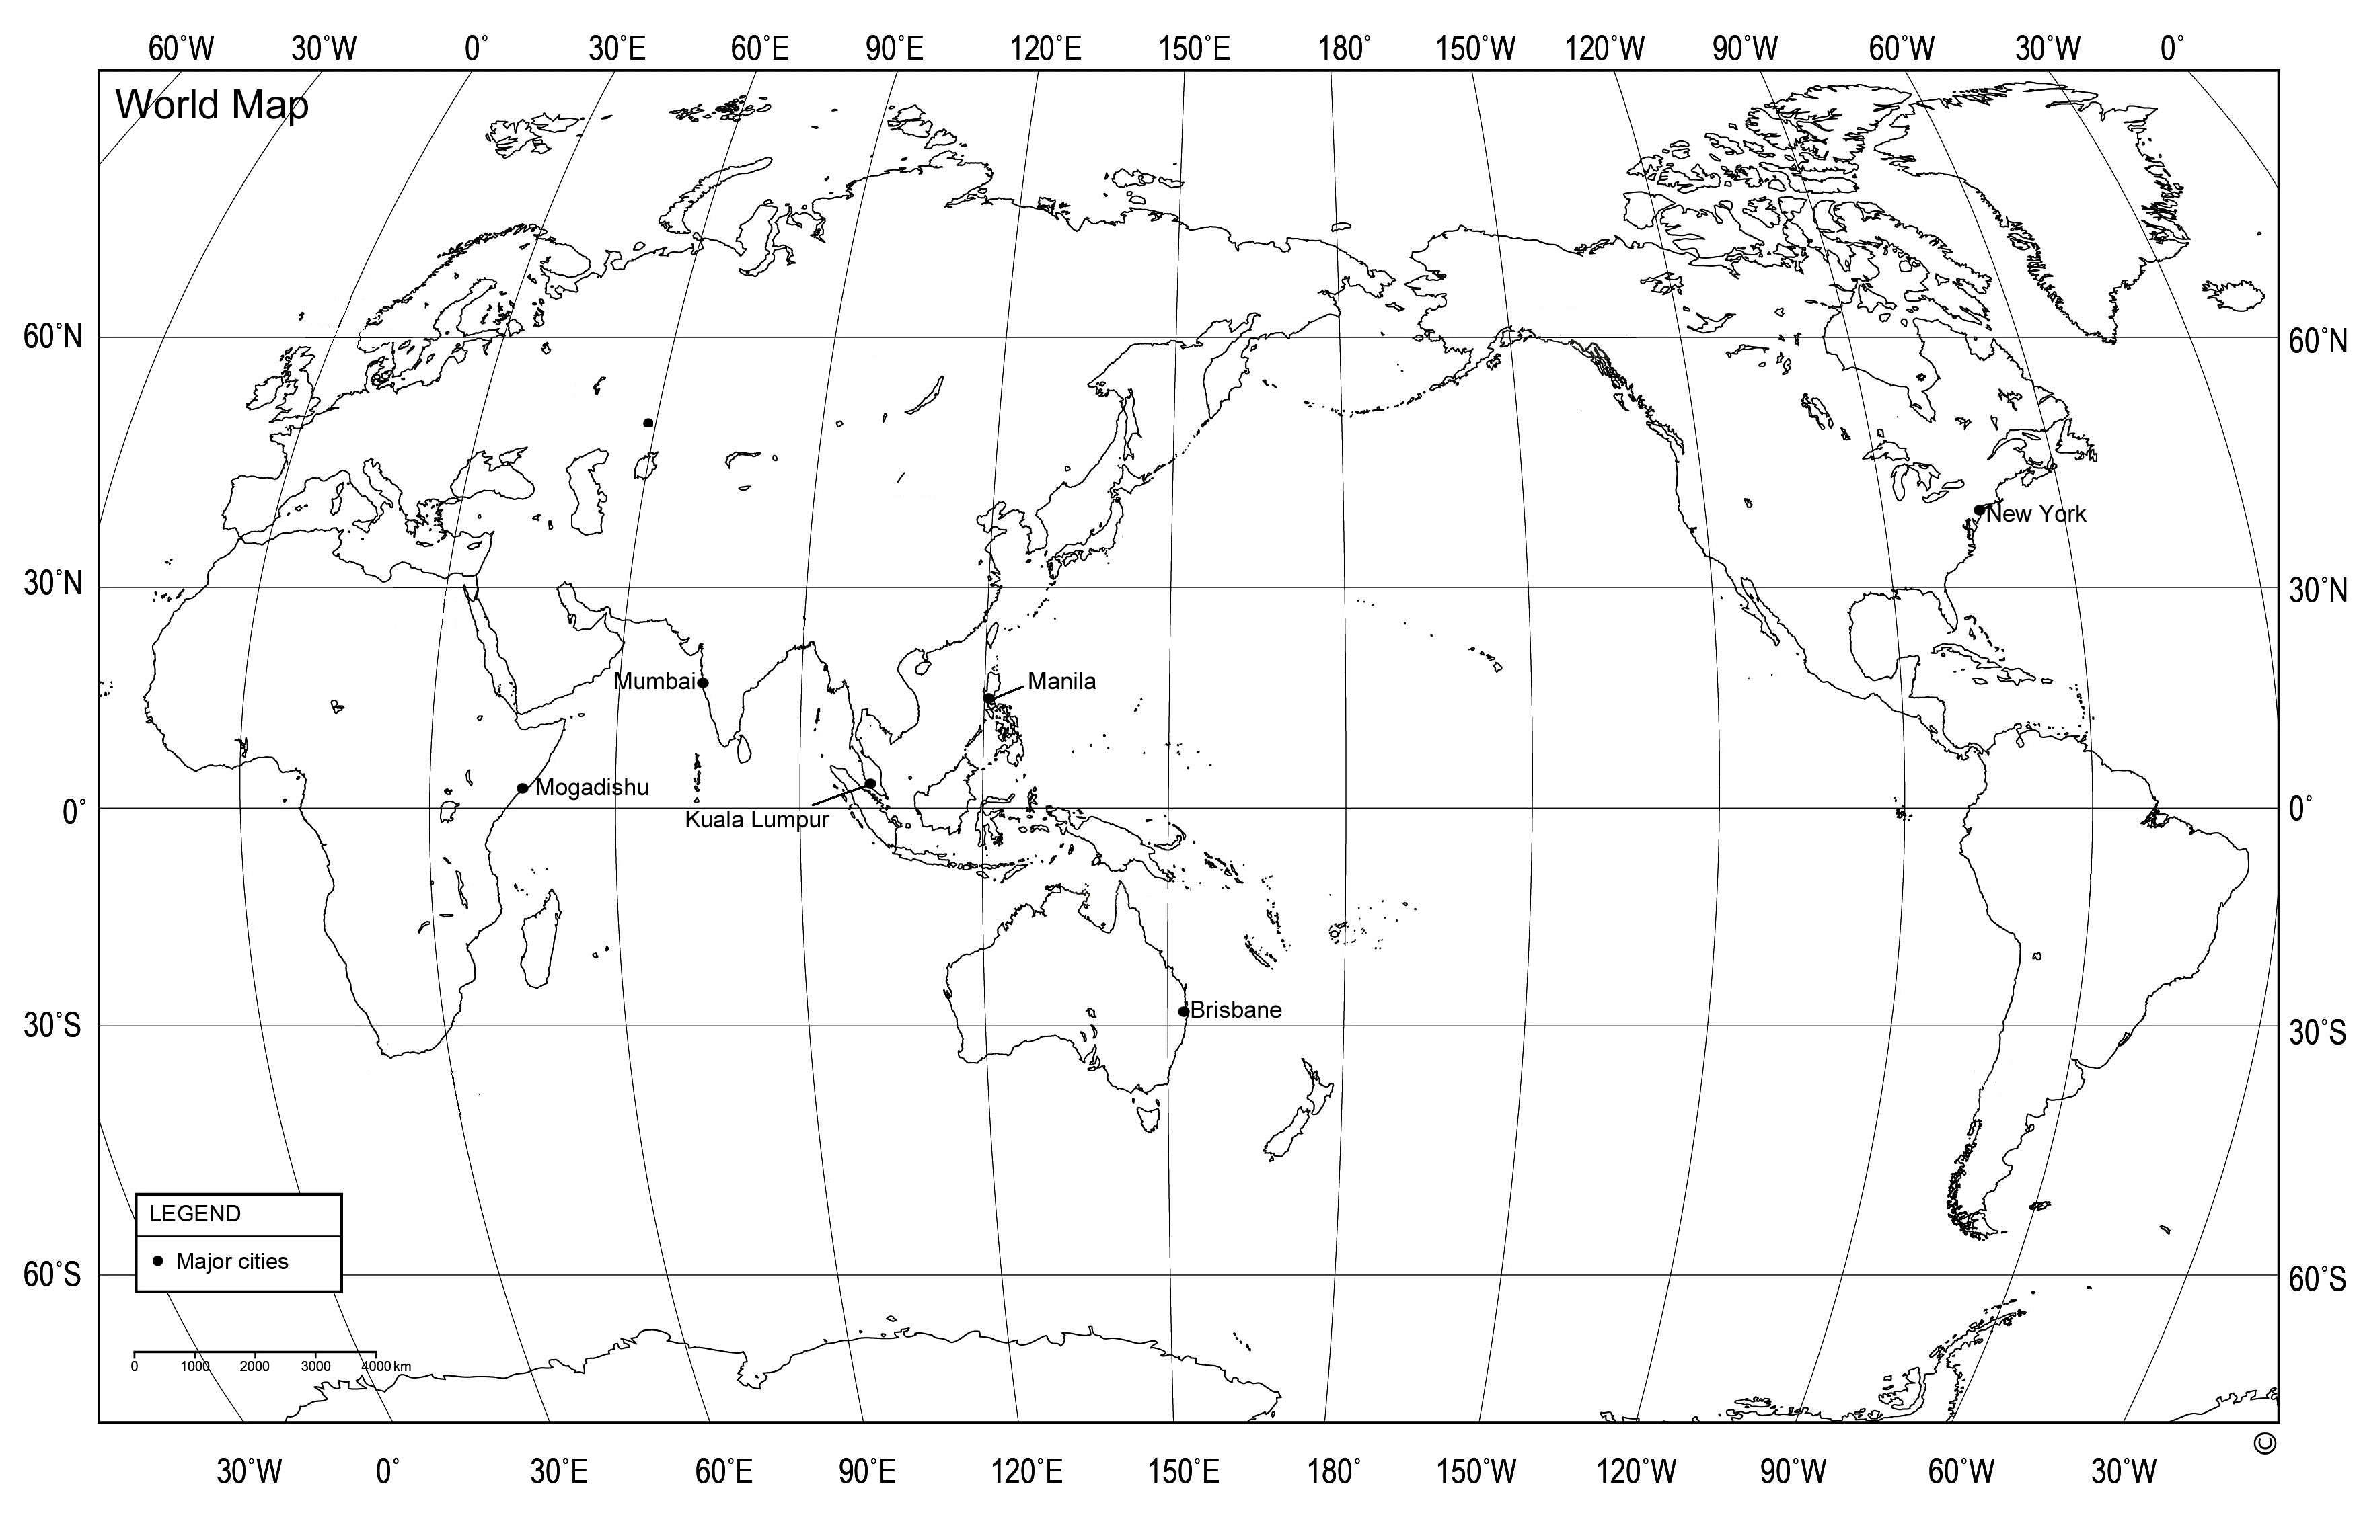

Source 2
Categories of GNI for selected countries in Asia 2015
GNI stands for Gross National Income. A country’s GNI per capita represents the average level of wealth of people living there.
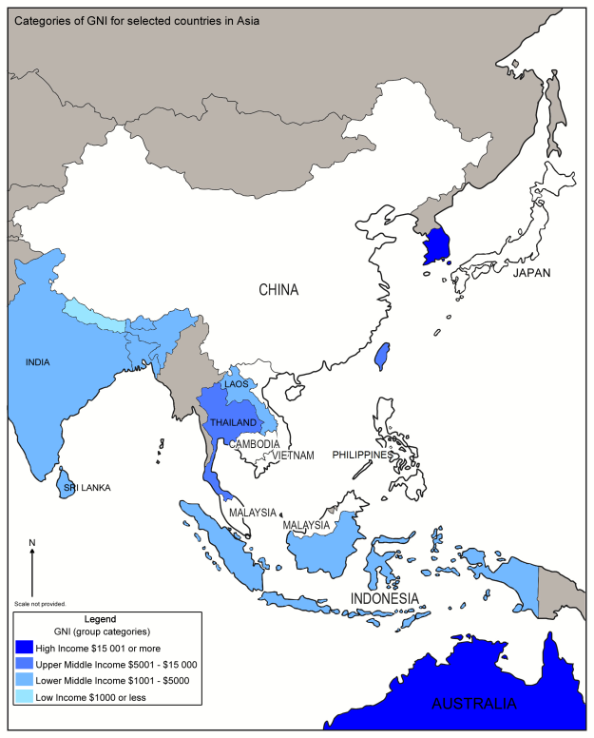
Data sourced from: The World Bank, GNI per Capita, Atlas method (current $US) http://data.worldbank.org/indicator/NY.GNP.PCAP.CD?locations=CN&view=map

Source 3  Annual Population Growth, Australia  — 2012 to 2015  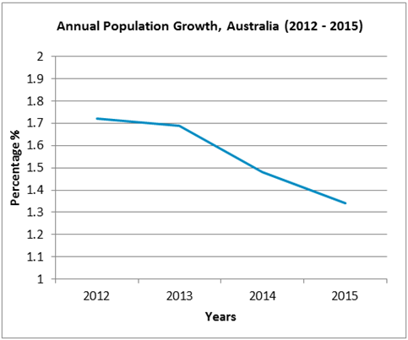 | Source 4  Annual Population Growth, Indonesia — 2012 to 2015  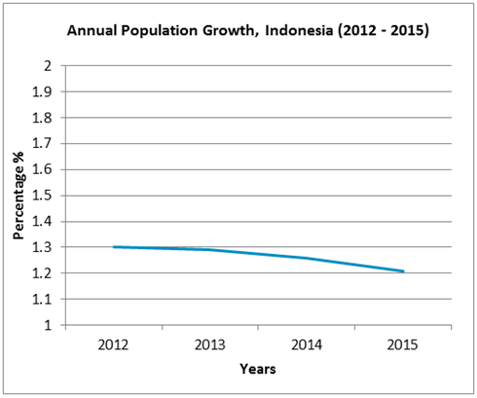
Data sourced from: The World Bank, Population Growth, http://data.worldbank.org/indicator/SP.POP.GROW?view=chart

Source 5
Country comparison table – Australia and Indonesia
 | Australia | Indonesia
Characteristics
Total population | 22 992 654 | 258 316 051
Percentage (%) of people living in rural areas | 11% | 46%
Percentage (%) of people living in urban areas | 89% | 54%
GNI | (US$) 60 070  High Income category | (US$) 3 440  Low Middle Income category
Life expectancy | 82 years | 73 years
Percentage (%) of the population with access to electricity | 100% | 81%
Percentage (%) of population with access to improved drinking water | 100% | 87%
Main exports | coal, iron ore, gold | mineral fuels  animal or vegetable fats/oils
Data sourced from: Central Intelligence Agency, The World Factbook, https://www.cia.gov/library/publications/the-world-factbook/geos/as.html
The World Bank, http://www.worldbank.org/

Source 6
Country comparison table — Australia and Japan
 | Australia | Japan
Characteristics
Location | Oceania; continent between the Indian Ocean and the South Pacific Ocean | East Asia; island chain between the North Pacific Ocean and the Sea of Japan
Land area (km2) | 7.7 million (km²) | 378 thousand (km²)
Terrain | island nation; mostly low plateau with deserts; fertile plains; mountain range along eastern coast | chain of islands; mostly rugged and mountainous
Climate | generally arid to semiarid; temperate in the south and east; tropical in the north | varies from tropical in the south to cool temperate in the north
Natural hazards | cyclones, severe droughts, forest fires, floods | volcanoes, earthquakes, tsunamis, typhoons
Environmental issues | the Great Barrier Reef off the northeast coast is threatened by increased shipping and tourism | air pollution from power plant emissions results in acid rain
Total population | 22 992 654 | 126 702 133
Main language spoken | English | Japanese
Main religions | Protestant and Catholic (European origin) | Shintoism and Buddhism (Asian origin)

Data sourced from: Central Intelligence Agency, The World Factbook, https://www.cia.gov/library/publications/the-world-factbook/geos/as.html

Source 7
The Dayak peoples, Borneo, South-east Asia
The Dayak peoples are indigenous peoples who live in the tropical, equatorial region on the island of Borneo (South-East Asia). Significant populations of these people can be found in both the Malaysian and Indonesian regions of Borneo.  There are many ethnic groups amongst the Dayak peoples, and there are about 140 different languages and dialects spoken.  Dayaks are accustomed to living in jungles and hard terrain and have knowledge of the plants and animals in these environments. Many become extremely good at following animal trails while hunting, and tracking humans or enemies.  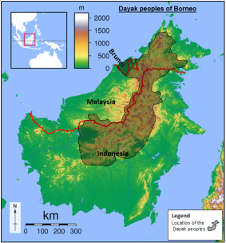  Sadalmelik, Borneo locator topography http://commons.wikimedia.org/wiki/File:Borneo_Locator_Topography.png  CC BY-SA 3.0 creativecommons.org/licenses/by-sa/3.0/deed.en | Traditionally, many Dayak people lived in communal longhouses built from timber obtained from rainforests. Dance and ceremony is an important part of religious ceremonies.  Dayak ceremony, http://en.wikipedia.org/wiki/File:Dayak_  ceremony.jpg  The Dayak peoples practise beadwork. The tajau, which is a type of ceramic jar made traditionally by men, is also a valued item. The symbols depicted on the pua kumba are often considered sacred, and the tajau is a traditional symbol of wealth and good fortune.  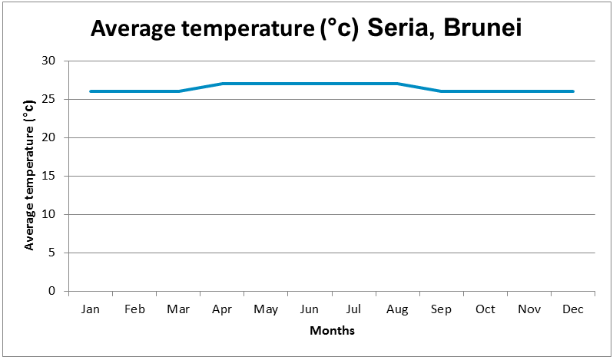  Data sourced from: weatherbase, http://www.weatherbase.com/weather/weather.php3?s=101694&cityname=Seria--United-States-of-America

Note: Aboriginal peoples and Torres Strait Islander peoples are warned that this resource may contain images and names of persons who may now be deceased.
Source 8
The Yolngu people, Arnhem Land, Australia
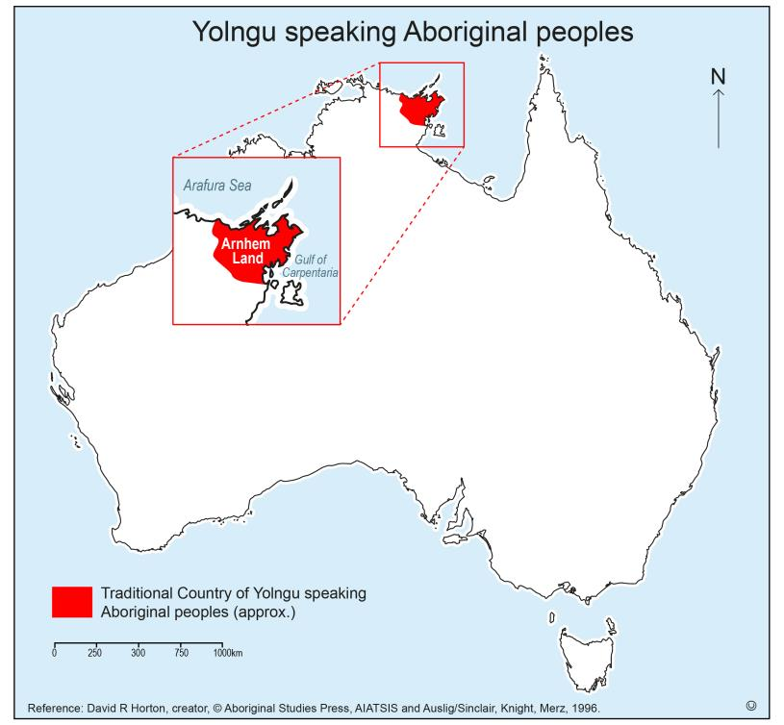 | The Yolngu people are Aboriginal Australians who live in the northeast of Arnhem Land in the Northern Territory. Yolngu people speak a dozen dialects of a language group known as ‘Yolngu Matha’. A dialect is a variation of a language.  Eastern Arnhem Land is the home of the yidaki, which is also known as the didgeridoo. These days the word, ‘yidaki’, applies to didgeridoos that are made by Yolngu people in eastern Arnhem Land and there are distinct differences, in their sound, structure and playing techniques that sets them apart from standard didgeridoos.  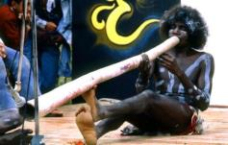  Nambassa Trust and Peter Terry, http://www.nambassa.com,  Arnhemland Aboriginal Performance on Open Air Theatre, http://commons.wikimedia.org/wiki/File:1981_Arnhemland_Aboriginal_Performance_on_Open_Air_Theatre.jpg CC BY 2.5 creativecommons.org/licenses/by/2.5/deed.en
Yolngu people are well known weavers. They weave *pandanus leaves and other fibres into baskets. Necklaces are also made from seeds, fish vertebrae or shells.  *Pandanus plants are common in the Northern Territory — they grow well in places that receive monsoonal rainfall.  Cheater, F, 1950, Stripping pandanus, Northern Territory Library, Photo number: PH0049/0654, http://www.territorystories.nt.gov.au/handle/10070/25583 Used with permission.  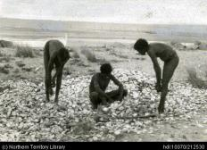  The Yolngu people hunt bush animals and collect *seasonal bush foods. Seafood, such as fish and shellfish (oysters), plays an important part in their diet.  *seasonal means only available at certain times of the year.  Barrett, C., Picking over pearl oyster shells, Northern Territory Library, Photo number: PH0741/0045, http://www.territorystories.nt.gov.au/handle/10070/212530 Used with permission | 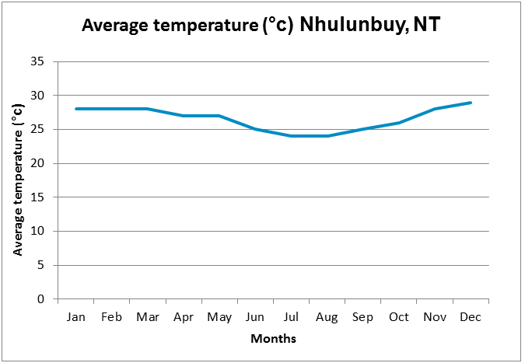  Data sourced from: weatherbase, http://www.weatherbase.com/weather/weather.php3?s=215410&cityname=Nhulunbuy-Northern-Territory

